Please read the following instructions carefully before solving & submitting assignment:

Uploading Instructions:
- You can use a simple text editor (like Textpad) or any IDE (e.g., NetBeans or IntelliJ IDEA) for this assignment.
Submission Requirements
- Submit all .java files (Employee.java, Teacher.java, Manager.java, and Test.java).
- Ensure your code is well-indented and includes comments explaining key parts.
- The program must compile and run without errors.
- After completion place all files in 1 folder and zip/compress the folder.
- Upload the zip/compressed folder on VULMS.

Rules for Marking:
It should be clear that your assignment will not get any credit if:

- The assignment is submitted after the due date.
- The assignment is not submitted in proper format (i.e., simple text, without any format/style).
- The assignment is fully or partially copied from other students or ditto copy from handouts or the Internet; strict disciplinary action will be taken in this case.

Note:
- No assignment will be accepted after the due date via email in any case (whether it is the case of load shedding or internet malfunctioning etc.). Hence refrain from uploading the assignment in the last hour of deadline.
- It is recommended to upload the solution at least one day before its closing date.
- Do not put any query on MDB regarding this assignment, if you have any query then email at cs506@vu.edu.pk

Lectures Covered: This assignment covers Lectures # 1 to 8

Problem Statement:
You are required to design and implement a class hierarchy representing different types of employees in a university using inheritance.
- Create a superclass named Employee with the following:
  - Attributes:
int id, String name, double salary
  - Constructors:
    - A parameterized constructor to initialize all attributes.
    - A default constructor that sets default values.
  - Methods:
    - void display() → Displays employee details.
    - String toString() → Returns a string representation of the employee.
- Create a subclass named Teacher that extends Employee:
  - Additional Attribute: String qualification
  - Constructors:
    - A parameterized constructor that calls the superclass constructor using super().
    - A default constructor.
  - Methods:
    - Override display() to include qualification.
    - Override toString() to include qualification.
- Create another subclass named Manager that extends Employee:
  - Additional Attribute: String department
  - Constructors:
    - A parameterized constructor that calls super().
    - A default constructor.
  - Methods:
    - Override display() to include department.
    - Override toString() to include department.
- Create a Test class that contains the main() method:
  - Create objects of all three classes: Employee, Teacher, and Manager.
  - Call their display() and toString() methods.
  - Demonstrate polymorphism by creating Employee references that refer to Teacher and Manager objects and call the overridden methods.
Sample Output
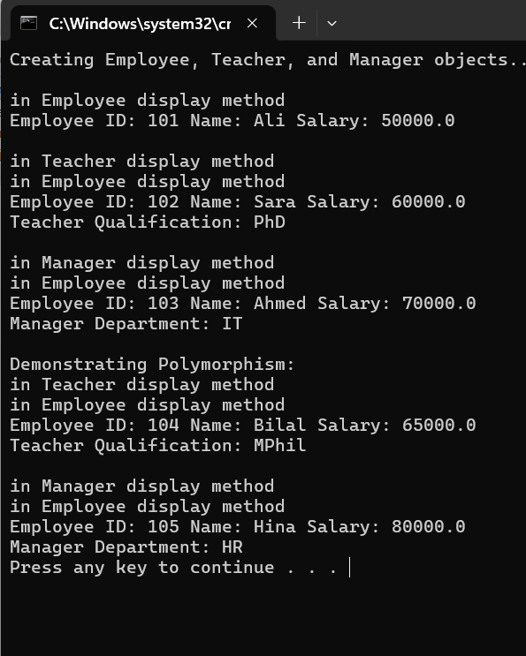
JDK Installation:
- To download & install JDK and create a HellowWorld program in Java, please watch.
https://vulms.vu.edu.pk/Courses/CS506/Downloads/JDK_Installation.mp4
- To download JDK setup file for Windows x64 from VU-LMS, please visit.
https://vulms.vu.edu.pk/Courses/CS506/Downloads/JDK_13.0.2_Windows_x64.zip
- To download JDK setup file for Windows x32 from VU-LMS, please visit.
https://vulms.vu.edu.pk/Courses/CS506/Downloads/JDK_8.251_Windows_x32.zip

Good Luck

